PE and Sports Premium – Impact Statement 2025-2026

Our PE and Sports Premium strategy for the academic year 2025-2026 involved the following intent:

- To Remove Barriers to Participation: Providing highly accessible, low-impact sports (like Boccia and target games) ensures that all pupils, regardless of their physical or cognitive needs, can actively participate in PE and school sports.
- To Support Sensory Regulation and Readiness to Learn: Integrating specialised sensory play equipment to offer essential vestibular and proprioceptive input, helping pupils self-regulate, reduce anxiety, and transition back to classrooms focused and ready to learn.
- To Enhance Motor Skill Development: Target-driven games, balance bikes, and obstacle layouts are intentionally selected to improve both gross and fine motor skills, including core stability, bilateral coordination, balance, and spatial awareness.
- To Enrich Unstructured Times: Introducing structured playground equipment to transform break times and lunchtimes into meaningful opportunities for active play, reducing sedentary behaviour.
- To Foster Social Communication and Life Skills: Utilising group games to naturally reinforce vital social skills such as turn-taking, sharing, patience, teamwork, and positive communication among peers.
- To Build Physical Confidence and Independence: Offering progressive equipment (like balance bikes) that builds self-esteem, celebrates personal achievement, and promotes independent movement and lifelong physical activity habits.

Impact
Swimming
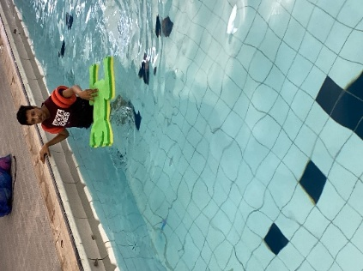
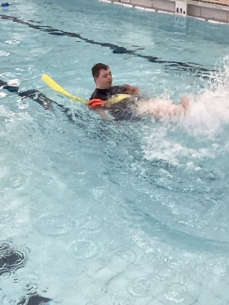
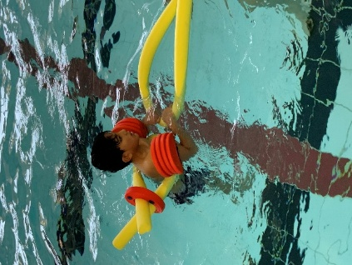

Although our Year 6 cohort are provided with weekly swimming tuition, it is important to note that their learning and physical difficulties have a significant impact on their ability to meet the national curriculum requirement to swim competently, confidently and proficiently over a distance of at least 25 metres, using a range of strokes effectively and to perform safe self-rescue in different water-based situations.

% of our Year 6 pupils who can swim competently, confidently and proficiently over a distance of 25m | 31%
% of our Year 6 pupils who are able to use a range of strokes effectively | 46%
% of our Year 6 pupils who are able to perform safe self-rescue in different water based situations | 16%

Cornhole, Boccia and New Age Kurling
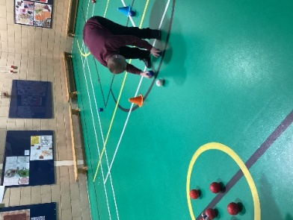
Enhancing Accessibility: The introduction of Boccia, Cornhole, and New Age Kurling has significantly increased participation by providing highly accessible, low-impact sports that allow pupils of all physical abilities to compete alongside one another.

Motor Skill Development: These targeted games have successfully enhanced pupils' fine motor control, hand-eye coordination, and spatial awareness through deliberate aiming and throwing actions.

Social & Emotional Growth: Pupils have developed vital communication and turn-taking skills, fostering a strong sense of team spirit, sportsmanship, and shared achievement.

Balance Bikes + Obstacles
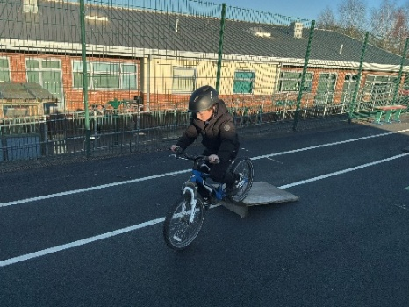
Gross Motor & Coordination: Utilising balance bikes paired with structured obstacle ramps has accelerated the development of gross motor skills, bilateral coordination, and lower-body strength.

Confidence & Spatial Awareness: Navigating the outdoor track and overcoming physical obstacles has vastly improved pupils' spatial awareness, risk management, and overall physical confidence.

Pathways to Independence: This equipment provides a foundational stepping stone toward independent cycling, boosting pupils' self-esteem and encouraging lifelong physical activity. Several pupils who have learned to ride two wheeled bicycles have been bought new bicycles and are now participating in family cycling activities.

Sensory Play Equipment

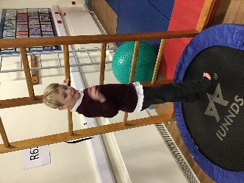
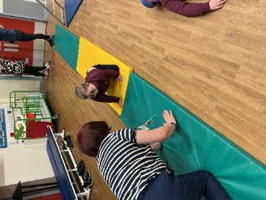
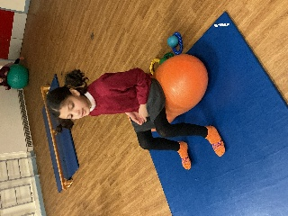
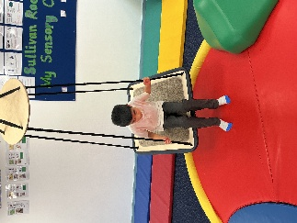

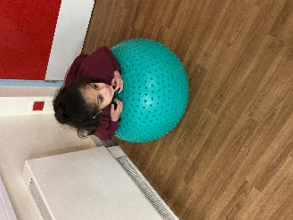
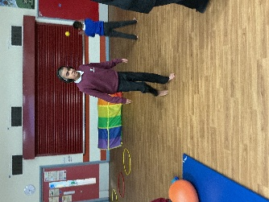
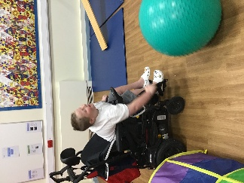
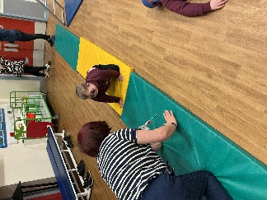

Vestibular & Proprioceptive Regulation: The new sensory play equipment—including swings, tunnels, trampolines, and therapy balls—offers crucial vestibular and proprioceptive input, helping pupils regulate their nervous systems effectively.

Core Strength & Physical Therapy: Active engagement with the gym mats and peanut balls has directly supported physical therapy goals, improving core stability, muscle tone, and balance for pupils with diverse mobility needs.

Readiness for Learning: Integrating these sensory-physical breaks throughout the school day has not only boosted physical health but has also markedly improved pupils' focus, emotional regulation, and readiness to engage in classroom learning.

Playground Game Equipment
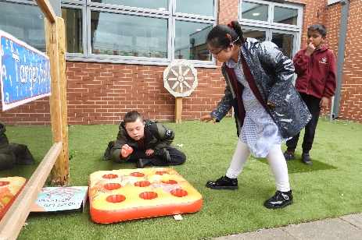
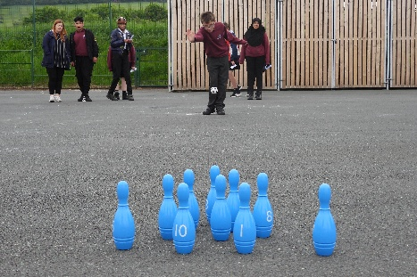
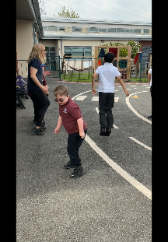

Promoting Structured Active Play: The introduction of targeted playground game equipment—such as outdoor bowling and target toss games—has revitalised break times, providing structured, purposeful physical activity options for our pupils."

Developing Motor Precision: Engaging with these interactive floor and lawn games has supported pupils in refining their gross and fine motor skills, specifically improving depth perception, throwing accuracy, and physical control.

Fostering Social Interaction and Turn-Taking: These inclusive playground activities have significantly boosted peer-to-peer interaction, helping pupils naturally practice turn-taking, patience, and positive communication in an informal outdoor setting.

Enhancing Concentration and Focus: Participating in these fun, goal-oriented games during break times has successfully provided pupils with positive physical outlets, leading to improved concentration and a calmer transition back into classroom learning.

