
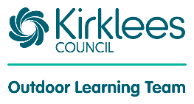
Wild Activities Challenging Kirklees Young People


‘Summer WACKY 2026’
Information & Booking Form

WACKY offers a packed programme of activities for young people with disabilities aged 10 - 24 to take part in over the holidays. Projects will be based at Little Deer Wood Activity Centre Shepley Bridge Marina, Huddersfield Road, Mirfield. WF14 9HR. Activities will run from over several days in the summer holiday from 10.30am – 3.30pm, please see the booking form for exact dates. There will be an opportunity to choose from different activities each day.

The activities on offer may include arts, crafts, DJ workshops, circus skills, digital photography, and music. The more energetic amongst you will enjoy a choice of sporting activities which could include canoeing, cycling, bush craft, archery, and rock climbing.

Please come dressed for activities and the season with suitable clothing, footwear and a waterproof jacket, which should prepare you for our varied British weather.

WACKY is an activity programme and we welcome all young people with a disability, however we do not have staff to provide one-to-one or two-to-one support. We would encourage you to come along with your personal assistant/carer if required; this has been the case over many years and has worked well. If you are new to WACKY a member of staff will contact, you after receiving your booking form to discuss your child’s needs further and arrange a pre-visit if necessary.

The meeting point for drop off and pick up each day will be at St Paul’s Church, Newgate, Mirfield WF14 8DD (please see next page for more directions). Those who require accessible parking can go straight to Shepley Bridge Marina, please let us know if this is required in advance.

The cost of WACKY is £15 per person per day. We have been fortunate enough to receive some funding which will enable us to provide lunch but if your child would prefer to bring their own packed lunch, they are more than welcome to do so. Please indicate this on the booking form. In all cases, please complete the dietary needs on the booking form.

To book your place please complete and return the attached registration form and send it to the office at the address below. We have limited capacity per age group so to avoid disappointment a prompt reply is advised. It is recommended that you keep a note of all the dates you have booked to avoid any confusion.

Please don’t hesitate to give us a call on the number below if you require any further information. I believe we have the perfect ingredients for a fantastic project. All we need now is you, so don’t delay book today.

Yours faithfully,

Heidi Langton

Outdoor Learning and Little Deer Wood Team Leader

Little Deer Wood Activity Centre, Shepley Bridge Marina, Huddersfield Road, Mirfield, WF14 9HR
Kirklees Reg No: 211275375
littledeerwood@kirklees.gov.uk Tel: 01484 225952 www.kirkleesdofe.org

Little Deer Wood Shepley Bridge Marina
Huddersfield Road, Mirfield. WF14 9HR

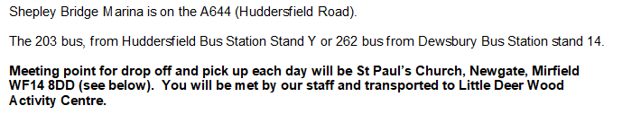
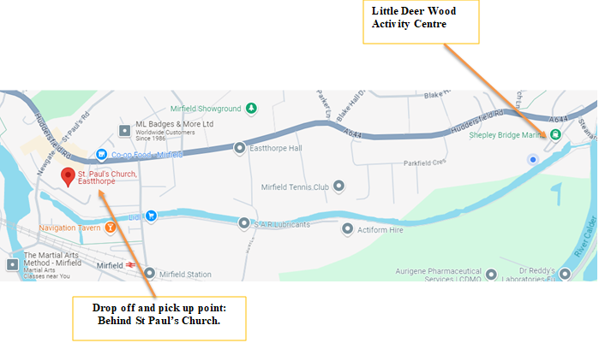

Church is accessed from Newgate, if coming on Huddersfield Road turn down the road towards the canal by Speights Lighting shop. Please park around the back of the church where there are 2 car parks. If you can please drive up the ramp and park on the top car park as it will allow us to turn the bus around on the bottom car park. If the top car park is full please park as near to it as you can.


Booking Form Little Deer Wood Summer WACKY 2026
This form can also be completed online by selecting the
link below or using the QR code.
WACKY Booking Form Summer 2026 – Fill in form

Please complete all sections marked with an *
Name*
Has the young person attended before?*
Date of Birth*
Age on event*
Gender
Pronoun/s (he/him, she/her, they/them…)
Ethnicity
Address*

Email*
School/College Attending:
Emergency Contact (Name, Phone Number, Relationship) *
Dietary Needs*
(e.g. vegetarian, halal, gluten free…)
Please state if you would like the lunch that is provided * | Yes - I would like lunch  No - I will bring a packed lunch
Is the young person in receipt of free school meals?
Details of disabilities*
Does the young person have a care plan? *If yes, please can you share this with us.
How does the above affect daily functioning? *
How does the young person communicate? *
What level of support does the young person require? *
Please note we do not provide 1:1, 1:2 care.
If 1:1 or 1:2 support is required who will be attending with the young person?
Does the young person require use of any specialist equipment? *
What is the young person’s level of dependency for toileting? *
What significant risks affect the young person? *
Does the young person become distressed or aggressive, how is the situation best dealt with? *
Does the young person have any ongoing medical concerns? E.g., asthma, epilepsy…*
Does the young person take any medication?
Would they need to take any medication during WACKY? Please detail. *
Does the young person have any allergies? Please detail. *

Statement of Consent – Please circle permission appropriately.

I am aware that the WACKY scheme may include sports, recreational, arts and craft, advice information and guidance, media, health, and food related projects*. | Yes | No
I confirm the details of the participant are correct. * | Yes | No
I know of no medical reason why the Young Person named above should not take part in any activities unless stated. * | Yes | No
I understand during the scheme photographs and video footage may be taken and that images could be used for promotion and evaluation. I consent to my child’s images being used. * | Yes | No
I agree that information may be shared with relevant partner agencies, to secure help for any young person named, through available support and guidance. * | Yes | No
I agree that those in charge may give medical treatment in an emergency. * | Yes | No
General Data Protection Regulation (GDPR) and Data Protection Act 2018 The information you provide to Kirklees Council is necessary for project management, development and audit and will be used for those purposes only. The DofE Team may share it with other Council Services and Partner Agencies where this is necessary for and consistent with the stated purposes. You can view Kirklees Council policies via http://www.kirklees.gov.uk/privacy.

I understand that it is important for everyone’s safety that any rules and instructions given by activity scheme staff are followed. I undertake to inform the Leader of any changes in the young person’s health prior to the activity scheme.

Name of Person completing record: _______________________________________________
Relationship to participant (if applicable) __________________________________
Signature __________________________________ Date ______________
Wk | Please indicate by ticking the appropriate box which days you would like to join in the WACKY Programme
1 | Mon 20th July |  | Tues 21st July
2 |  |  |  |  | Wed 29th July |  | Thurs 30th July |  | Fri 31st July
3 |  |  | Tues 4th August |  | Wed 5th August |  | Thurs 6th August |  | Fri 7th August
4 | Mon 10th August |  | Tues 11th August
5 | Mon 17th August |  | Tues 18th August |  | Wed 19th August |  | Thurs 20th August |  | Fri 21st August

