Strategies | Cost | Impact
Use of additional teacher for Key Stage 3 to enable an extra class and therefore create smaller groups.  Use of two additional ETAs to allow capacity for delivery of ELSA and Trailblazer support. | £42,000 | Percentage of PP pupils achieving or exceeding academic targets is broadly in line with non-PP pupils in English and Maths.  Attendance figures for pupil premium pupils are in line with non-pupil premium with both at 91%  Percentages of pupil premium pupils achieving holistic targets are in line with, or higher, than non-pupil premium percentages in Cognition and Learning, SEMH and Sensory and/or Physical. They are slightly below in communication and interaction.
Use of two additional ETAs to allow capacity for delivery of weekly one to one and small group sessions in English and Maths, in addition to standard lessons. | £44,520
Assistant headteacher leading SEMH provision  TLR for communications lead  Appoint lead English and Maths teaching assistant to implement intervention strategies | £10,966  £4070  £2840
Total Cost | £104,396
Financial Summary
Pupil Numbers | Allocation
21 Primary pupils | £30,643
73 Secondary pupils | £76,737
Total allocation | £107,200
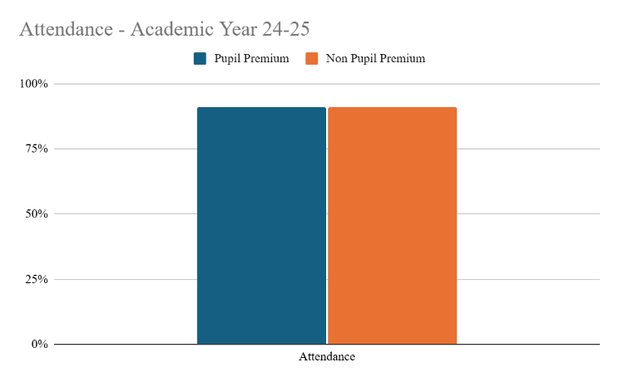
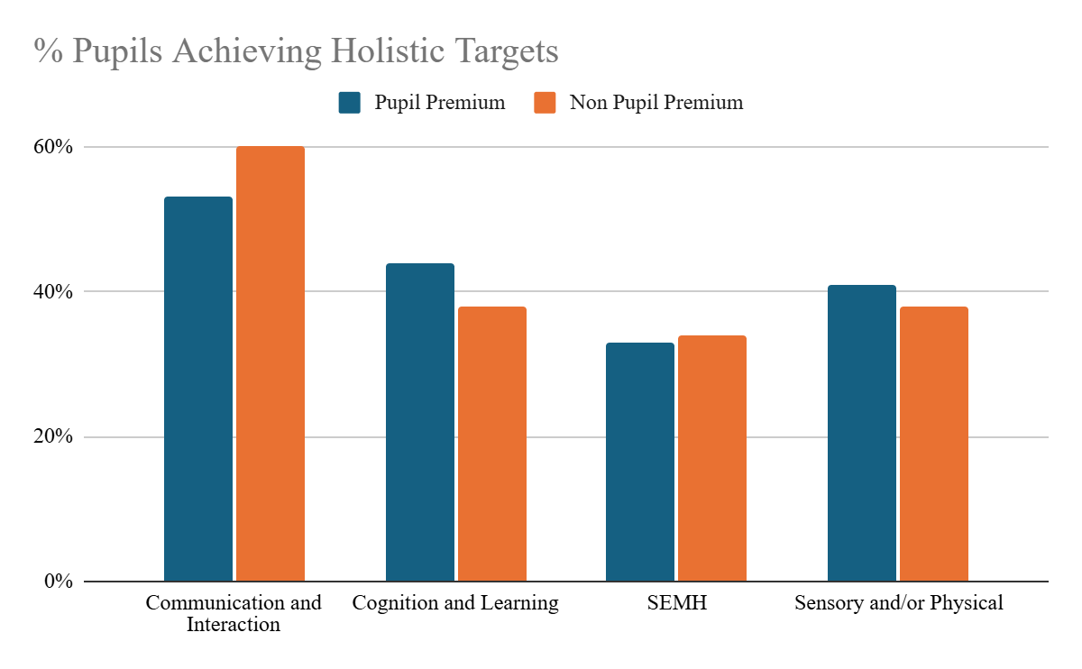
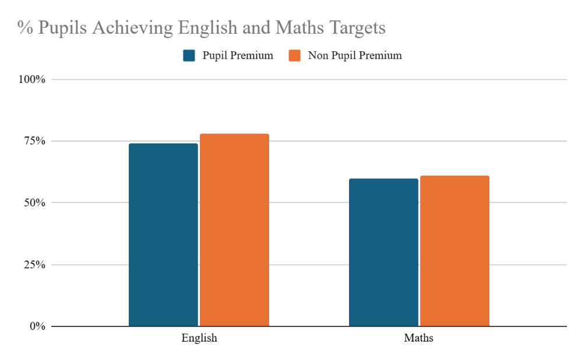

ca
Strategic Summary: At Ravenshall school, pupil premium funding is used to ensure that pupils can achieve academic and holistic progress in line with or better than their non-pupil premium peers.
Pupil Premium Impact Statement 2024-25

