PE and Sports Premium – Impact Statement 2023-2024

Our PE and Sports Premium strategy for the academic year 2023-2024 involved the following intent:
- Improve the overall provision of PE in the primary department through purchase of specialist equipment, training for staff and assistance from qualified sports coaches.
- encourage pupils to take part in structured sporting activities during lunch breaks.
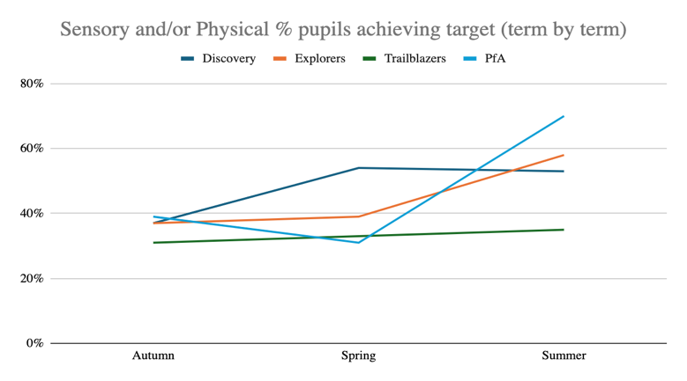
The impact of these strategies has been measured through recording percentages of pupils achieving termly sensory and/or physical targets, as well as looking at softer data e.g case studies of pupils who have achieved individual success because of the implemented strategies.

Percentages of pupils in our primary department who have achieved their termly sensory and physical targets have increased over the course of the year due to increased opportunities to take part in a variety of physical activities.
Swimming
Although our Year 6 cohort are provided with weekly swimming tuition, it is important to note that their learning and physical difficulties have a significant impact on their ability to meet the national curriculum requirement to swim competently, confidently and proficiently over a distance of at least 25 metres, using a range of strokes effectively and to perform safe self-rescue in different water-based situations.
% of our Year 6 pupils who can swim competently, confidently and proficiently over a distance of 25m | 18%
% of our Year 6 pupils who are able to use a range of strokes effectively | 40%
% of our Year 6 pupils who are able to perform safe self-rescue in different water based situations | 72%

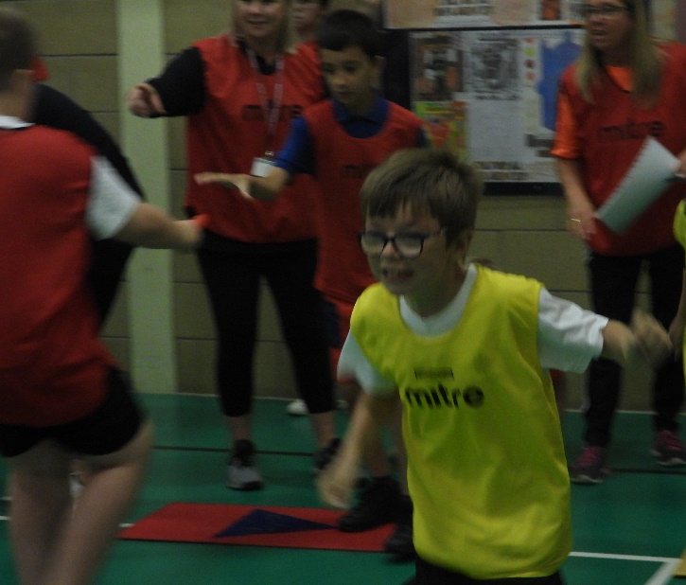
Sports Leaders
Our primary sports leaders have been involved in supporting staff in the delivery of sports activities and organising events such as football tournaments. This has continued to develop their enthusiasm for physical activity as well as provide opportunities to develop leadership, communication, and organisational skills through sport.

Countryside Walking
Several of our pupils have participated in countryside walking as part of our Wonderful Wednesday enrichment programme. Pupils have developed a greater interest in their local area and report that they have begun to go out walking with their family members outside of school time.



