Strategies | Cost | Impact
Use of additional teacher for Key Stage 3 to enable an extra class and therefore create smaller groups.  Use of two additional ETAs to allow capacity for delivery of ELSA and Trailblazer support. | £41,413 | Percentage of PP pupils achieving or exceeding academic targets is in line with non-PP in English and is significantly higher in Maths.  Attendance figures for pupil premium pupils are in line with non-pupil premium  Percentages of pupil premium pupils achieving holistic targets are broadly in line with non-pupil premium percentages.
Use of two additional ETAs to allow capacity for delivery of weekly one to one and small group sessions in English and Maths, in addition to standard lessons | £44,520
- TLR for Communications Lead  - Appoint assistant Headteacher leading teaching and learning  - Appoint lead English and Maths teaching assistant to implement intervention strategies | - £4070  - £10,966  - £2840
Assistant Headteacher leading SEMH provision | £10,966
Total Cost | £114,775
Financial Summary
Pupil Numbers | Allocation
21 Primary pupils | £30,555
66 Secondary pupils | £68,310
Total allocation | £98,865
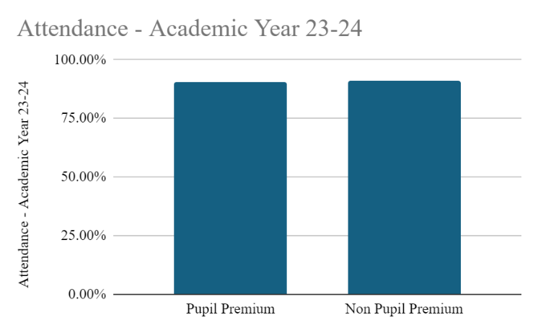
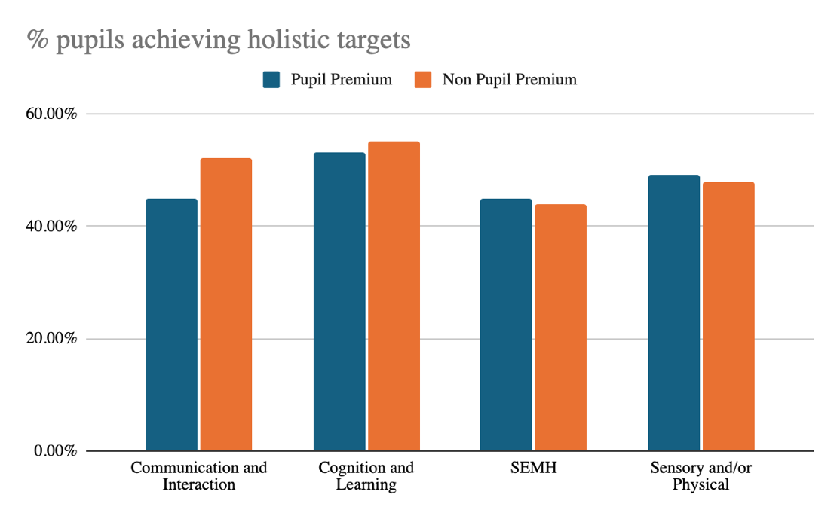
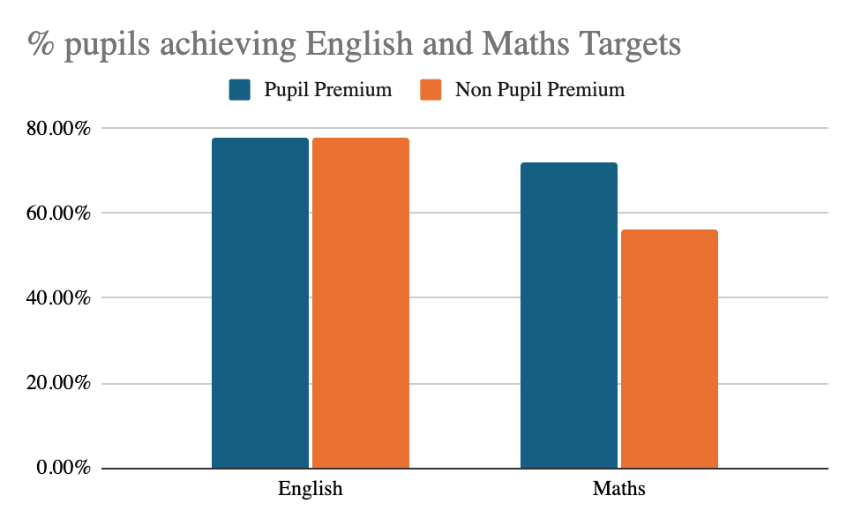

ca
Strategic Summary: At Ravenshall school, pupil premium funding is used to ensure that pupils can achieve academic and holistic progress in line with or better than their non-pupil premium peers.
Pupil Premium Impact Statement 2023-24

