

What is an ELSA?
An ELSA is a specialist teaching assistant with a wealth of experience of working with pupils. ELSA’s are regularly trained and supervised by the Educational Psychologists (EP’s) in Kirklees.
There will always be pupils in school facing life challenges that detract from their ability to engage with learning, and some will require greater support to increase their emotional literacy than others.
When our pupils find themselves struggling and encountering difficulties with their emotional health our ELSA’s are there to listen, provide additional strategies and support to remove the barriers to learning.
An ELSA is a warm and caring person who wants to help pupils feel happy in school and to reach their potential. We are very fortunate to have 4 qualified ELSA’S in our school.
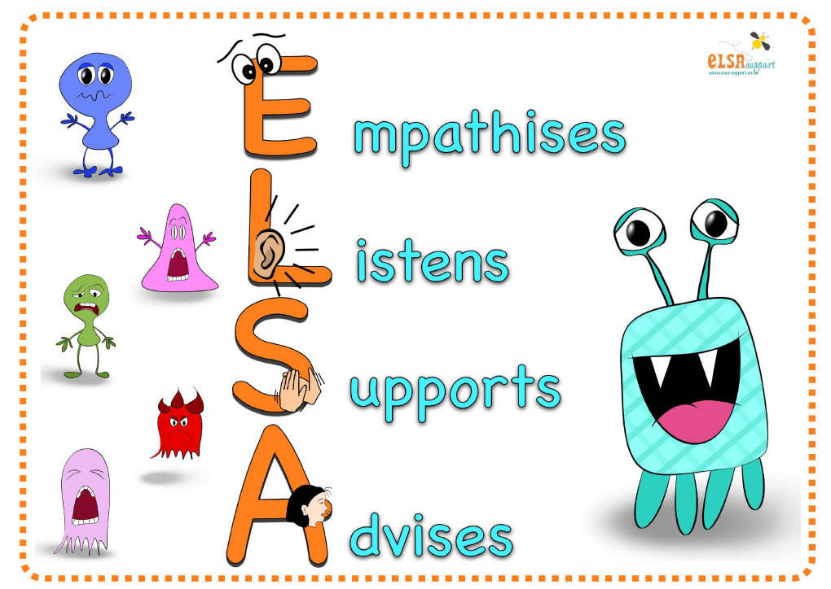
Meet Ravenhall’s ELSA Team


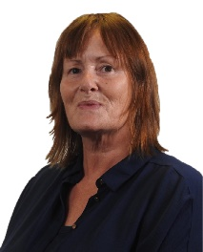

Mrs Turnbull Mrs Lewis Mrs Shaw Mr Armitage

Discovery & Trailblazers Trailblazers PFA Explorers & Trailblazers
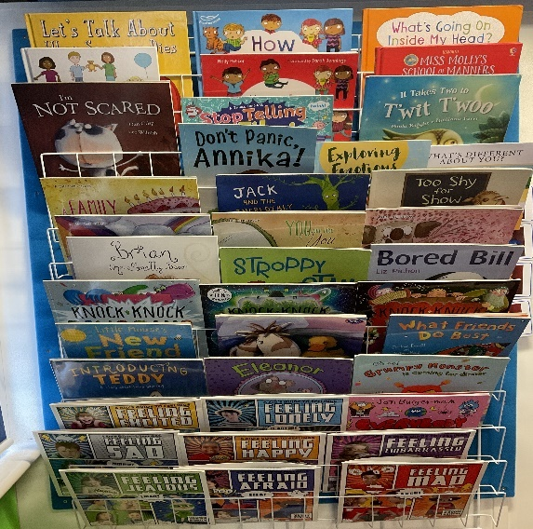
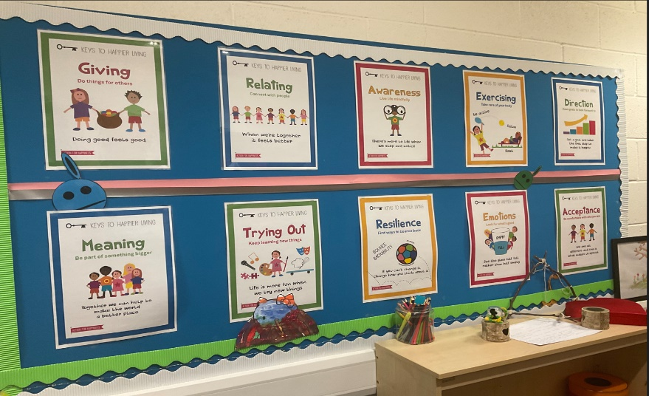
Each ELSA aims to establish a warm, respectful relationship with a pupil and to provide the same safe, reflective space in our pupil wellbeing room, where they are able to honestly share their thoughts and feeling to feel supported and nurtured.

Change is not necessarily achieved rapidly and is dependent upon the context and complexity of the presenting issues. For children with complex or long-term needs it is unrealistic to expect ELSA intervention to resolve all their difficulties.
An ELSA CAN’T necessarily fix a pupil’s problems, but they CAN provide emotional support.

How does ELSA work?
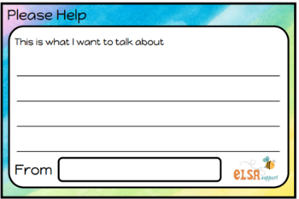
Pupils are referred for ELSA support by their class teacher, Inclusion Team Manager, AHT for SEMH. However, some of our KS3 & KS4 pupils will self-refer. The ELSA team meets every half term to discuss new referrals.
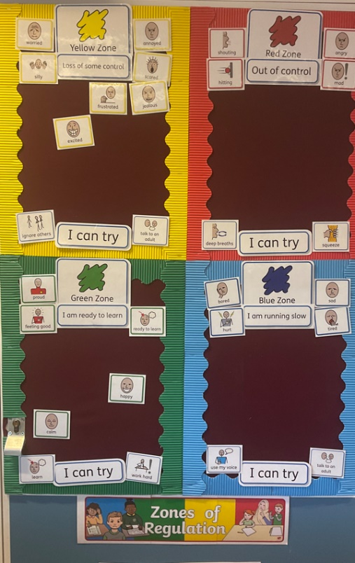
In ELSA we aim to provide support for a wide range of emotional needs:
- Recognising emotions
- Anxiety
- Self-esteem
- Social skills
- Conflict
- Friendship skills
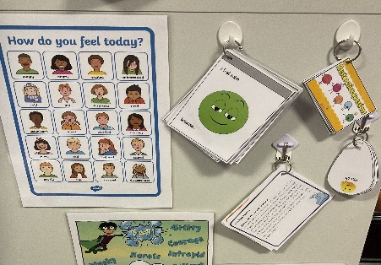
- Relationships
- Anger management
- Loss and bereavement
- Relaxation techniques
- Transition/ change

Timetabled Intervention Sessions
With the ELSA programme aims in mind, intervention support sessions last 30-50 minutes and are planned to facilitate the pupil in developing new skills and coping strategies that allow them to manage social and emotional demands more effectively. These sessions are fun and a range of activities such as games, role-play with puppets, arts and craft are used.
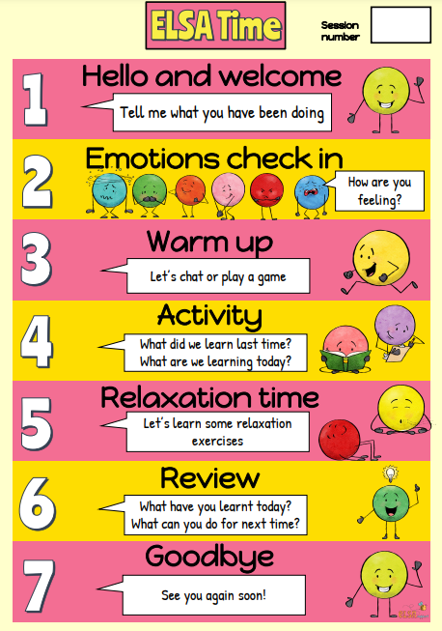
- Hello and welcome – is about checking in with the pupil. What have they been doing? Anything they want to tell you about?

- Emotions check in – how are pupils feeling?

- Warm up – a simple game, activity or a chat to warm up or break the ice.

- Activity – working on the session objective and a quick review on what you did last time.

- Relaxation time – a simple relaxation exercise or coping strategy such as breathing.

- Review of the session – what have pupils learnt? What could they do for next time?

- Goodbye – ending the session with the pupil.

Additional Support

Sessions are delivered on an individual basis; however, sometimes small group work is more appropriate, especially in areas of friendships and social skills.

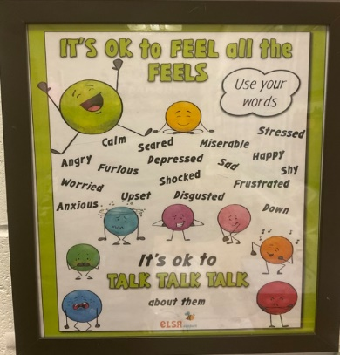

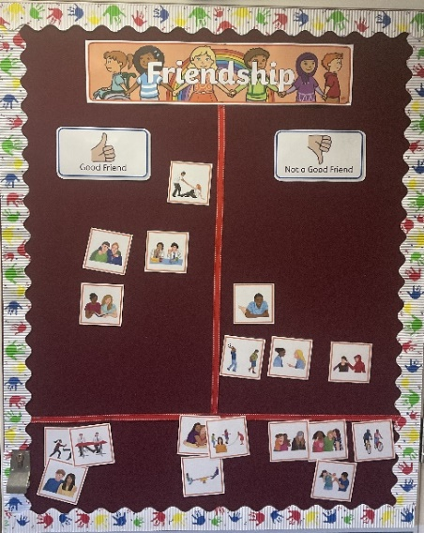
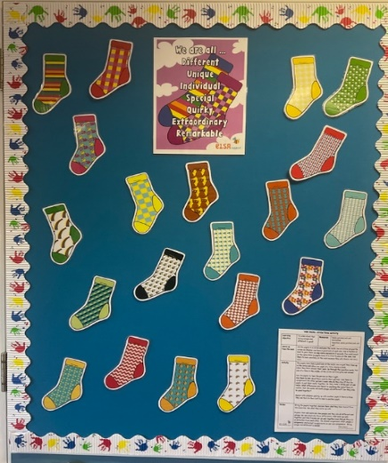

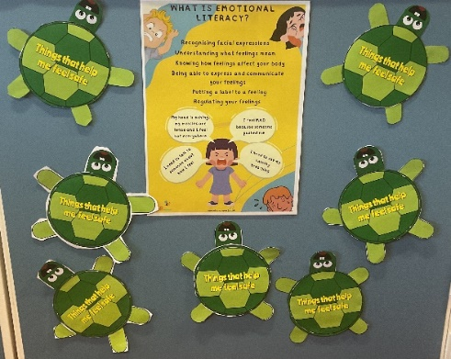

Additional Support
If additional support is required the ELSA team will refer this to the SEMH lead, who will lease with external agencies for further work with families to support the pupil.

What do the pupils think?
On completion of ELSA, pupils are asked to reflect on their experiences and to give feedback. Here are some of the lovely comments received:
‘I like coming to ELSA, it makes me feel happy’.
‘Elsa has helped me to make new friends.
‘I use some of the strategies to keep calm at home too’.

​​​​​​​​​​​​​​
‘I use Zones of regulation in my lessons now to help me’.
‘I look forward to my ELSA sessions. It is good to know someone listens to me’.

‘Elsa has helped me with confidence’.

Click on the link below for further ELSA information and free resources.
https://www.elsa-support.co.uk/category/free-resources/

