Summer 2025 Online Safety Newsletter

Teens, Social media and you
“Teens, social media & you” is a guide from media smart and Tiktok, designed for parents and carers of teens aged 13+. It helps adults understand the online world their young person is navigating, offering tips to support safe, balanced use of social media through open conversation and active involvement. You can find lots of advice here:
https://mediasmart.uk.com/tiktok-teens-social-media-and-you/
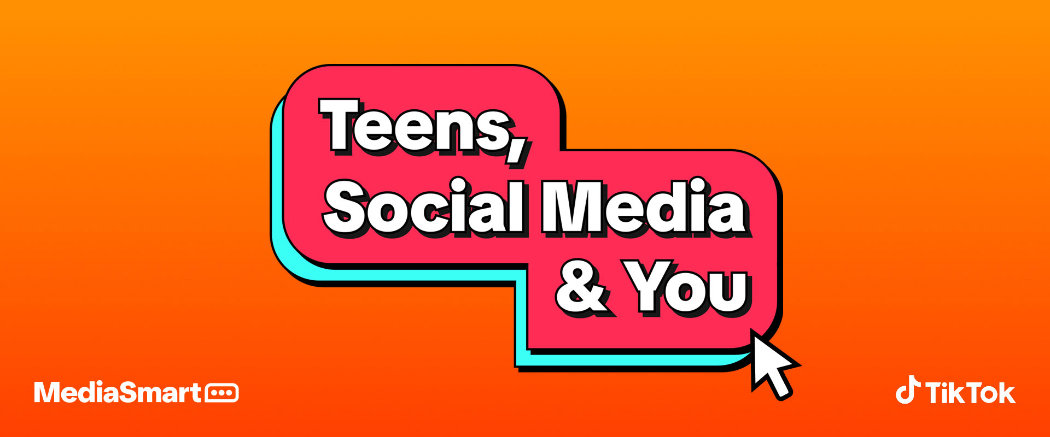
Kick
Many parents and carers are familiar with Twitch, a popular live-streaming platform for gamers. Due to controversies over its restrictions, alternatives like Kick have gained popularity. Launched in 2022, Kick follows a similar model where users (13+) can stream and earn money. However, much of its content is adult in nature, making it important for parents and carers to be aware of the platform and its potential risks for our students. Here is a guide to help:
https://www.internetmatters.org/hub/news-blogs/what-is-kick-streaming/


Nintendo Switch 2
GameChat is included within a Nintendo Switch Online membership and allows up to 12 people to chat while playing games. Players can share their screen, chat with the built-in microphone and as the Nintendo Switch 2 allows cameras to be connected (sold separately), even video chat. You can find out more here:
https://www.nintendo.com/engb/Hardware/Nintendo-Switch-2/GameChat/Nintendo-Switch-2-GameChat2785625.html
Parental Controls
There is a free Nintendo Switch Parental Controls app that can be linked with your Nintendo Switch to monitor what your child is playing. The app creates a report so you can see which video games your child is playing and for how long. It also allows you to set which games your child can play, based on the PEGI age rating and restricts your child from sending or receiving messages from other users. GameChat settings can also be adjusted. Children under the age of 15 can only use GameChat if allowed by you through the app. They can then only use GameChat with people that you approve. Find out more here:
https://www.nintendo.com/engb/Support/Nintendo-Switch-2/How-to-Set-Up-Adjust-or-Remove-ParentalControls-on-Nintendo-Switch-2-2843839.html
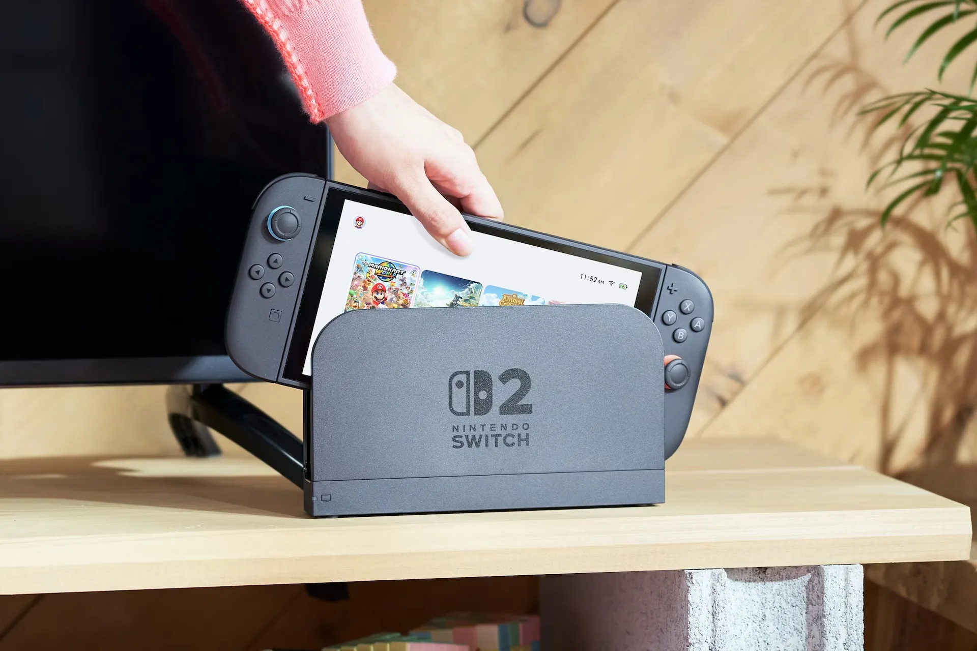

Gaming
With the summer holidays nearly here the "Game Safe" guide from Internet Matters helps parents and carers support safe, balanced online gaming for young people. It covers age-appropriate content, managing screen time, setting parental controls, and staying alert to online risks like in-game chats and spending. It also encourages open conversations to promote safe and positive gaming experiences. Here is the link to the guide:
https://www.internetmatters.org/wp-content/uploads/2020/04/Internet-Matters-Gaming-Guide-to-support-young-people.pdf

