

2024 Pupil outcomes

REPORT



**2023 – 2024 Pupil Outcomes**

At Ravenshall we assess pupil progress in English, Maths (ABC Assessment) and towards individual EHCP outcomes (Holistic Targets).

**ABC Assessment Outcomes**

In English and Maths, pupils are set annual targets from their individual starting points, based on a bespoke progression guidance. The progression guidance has been calculated based on several years of progress data and takes into consideration how rates of progress differ depending on pupil age and cognitive starting points.

**Holistic Target Outcomes**

Holistic targets are smaller steps towards individual end of key stage EHCP outcomes.

English

The charts below show percentages of pupils that met the annual rate of progression by phase in each strand of English. They also show how pupil premium pupils achieved in comparison to other pupils.

The table below shows percentages of other specific groups of pupils that met the annual rate of progression.

|  |  |  |  |  |  |
| --- | --- | --- | --- | --- | --- |
|  |  |  | % on track | | |
| Phase | Group | Total Pupils | SLC | Reading | Writing |
| Discovery | LAC | 2 | 0% | 0% | 50% |
| Girls | 11 | 91% | 91% | 100% |
| Boys | 22 | 73% | 82% | 73% |
| Explorers | LAC | 6 | 100% | 83% | 50% |
| Girls | 21 | 90% | 86% | 67% |
| Boys | 51 | 78% | 90% | 76% |
| Trailblazers | LAC | 0 | N/A | N/A | N/A |
| Girls | 13 | 92% | 77% | 69% |
| Boys | 35 | 83% | 77% | 51% |

Maths

The charts below show percentages of pupils that met the annual rate of progression by phase in each strand of Maths. They also show how pupil premium pupils achieved in comparison to other pupils.

The table below shows percentages of other specific groups of pupils that met the annual rate of progression.

|  |  |  |  |  |  |
| --- | --- | --- | --- | --- | --- |
|  |  |  | % on track | | |
| Phase | Group | Total Pupils | Number | G&M | Statistics |
| Discovery | LAC | 2 | 50% | 50% | 0% (1 pupil) |
| Girls | 11 | 91% | 100% | 100% (4 pupils) |
| Boys | 22 | 68% | 68% | 75% (4 pupils) |
| Explorers | LAC | 6 | 83% | 83% | 40% (5 pupils) |
| Girls | 21 | 81% | 67% | 20% (15 pupils) |
| Boys | 51 | 78% | 76% | 46% (48 pupils) |
| Trailblazers | LAC | 0 | N/A | N/A | N/A |
| Girls | 13 | 69% | 15% | 0% |
| Boys | 35 | 54% | 14% | 0% |

Holistic targets

The charts below show percentages of pupils that achieved their holistic target in each area. They also show how pupil premium pupils achieved in comparison to other pupils.

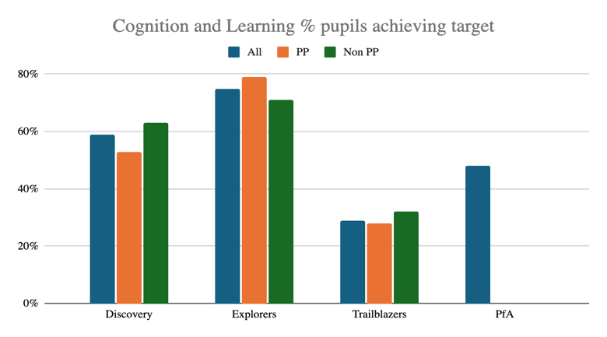

The table below shows percentages of other specific groups of pupils achieving their holistic targets.

|  |  |  |  |  |  |  |
| --- | --- | --- | --- | --- | --- | --- |
|  |  |  | % on track | | | |
| Phase | Group | Total Pupils | C&I | C&L | SEMH | S a/o P |
| Discovery | LAC | 2 | 50% | 100% | 50% | 0% |
| Girls | 11 | 73% | 82% | 45% | 64% |
| Boys | 23 | 52% | 48% | 39% | 48% |
| Explorers | LAC | 6 | 60% | 80% | 40% | 60% |
| Girls | 23 | 81% | 69% | 56% | 43% |
| Boys | 58 | 58% | 76% | 58% | 62% |
| Trailblazers | LAC | 0 | N/A | N/A | N/A | N/A |
| Girls | 13 | 0% | 15% | 38% | 46% |
| Boys | 35 | 31% | 34% | 31% | 31% |
| PfA | LAC | 1 | 100% | 0% | 100% | 0% |
| Girls | 8 | 17% | 50% | 67% | 83% |
| Boys | 28 | 41% | 48% | 63% | 70% |

END OF YEAR ACCREDITATIONS

Trailblazers Phase

|  |  |  |  |
| --- | --- | --- | --- |
| Subject | Entry Level 1 | Entry Level 2 | Entry Level 3 |
| NCFE Entry Level Functional Skills in English | 8 Pupils | 9 Pupils | 2 Pupils |
| NCFE Entry Level Functional Skills in Maths | 7 Pupils | 15 Pupils |  |
| AQA Science Entry Level Certificate | 1 Pupil | 7 Pupils | 9 Pupils |
| ASDAN Personal and Social Development Award | 10 Pupils | 12 Pupils |  |
|  | **Bronze** |  |  |
| Arts Award | Awaiting results |  |  |
|  | **Level 1** |  |  |
| Sports Leaders | 6 Pupils |  |  |

PfA (Post 16)

|  |  |  |  |
| --- | --- | --- | --- |
| Subject | Entry Level 1 | Entry Level 2 | Entry Level 3 |
| ASDAN Employability Award |  | 9 Pupils |  |
| OCR Life and Living Skills - Certificate | 13 Pupils |  |  |
| OCR Life and Living Skills - Extended Certificate | 4 Pupils |  |  |